WhiteHat Junior

PRO-C44

1. Space Warriors

2. Plane Shooting Game

1. One nice day in America,There was a message for police from aliens.

Message:

I am Thanos the king of the alien land.

We will keep a space war tomorrow.

If you win ok,but if we win the earth belongs

To us.we will be attack tomorrow be ready.

The police officer’s were so frightened.They informed to presedent named Trump of their country.The presedent informed to all presedents of every country.Then they held a meeting.They formed group of army to fight with aliens with spaceships in space.

The next day the time arrived,

The soldiers are one side and aliens other side in space.The war started they fighted with spaceship bullets and granides.But the aliens bought a secret weapon “Gatling”.It’s power is more than a atom bomb. But even earth soldires have a weapon “Plasma”.

But a problem is that one should carry the plasma to aliens main Spaceship.if the person carry it and fix it in aliens spaceship the plasma will burst in 5 minutes .So,one soldier should risk his life.The one soldier named “Krish” from India came infront to risk his life for people and then he took plasma and went to aliens ship.He fixed it in enemies spaceship.All soldiers taught krish died.But he escaped in 4 minutes 59 seconds. All aliens died and Even Alien king Thanos.

Because of Krish all People were saved in earth.All people thanked Krish.

THE END

1. Playing Characters

|  |  |  |
| --- | --- | --- |
| Number | Character Name | What can this character do? |
| 1 | Police officer’s | Catch criminals |
| 2 | Thanos | Alien King |
| 3 | Krish | Hero |
| 4 | Soldiers | Fight with aliens in spaceship |
| 5 | Presedents | Rule the country  And do peoples needs |
| 6. | Trump | America presedent |
|  |  |  |
|  |  |  |

5.Non-Playing Characters:

|  |  |  |
| --- | --- | --- |
| Number | Character Name | What can this character do? |
| 1 | Message | Receive message message from Aliens |
| 2 | Granides | Granides are bombs  Use to attack alien |
| 3 | Gatling | Enemy weopon  Alien Secret Weapon  To attack people in earth |
| 4 | Earth | Earth is place which humans live |
| 5 | Plasma | Soldiers weapon  Used to attack Aliens |
|  |  |  |
|  |  |  |
|  |  |  |

Character pictures of my game:

Playing characters

Police:

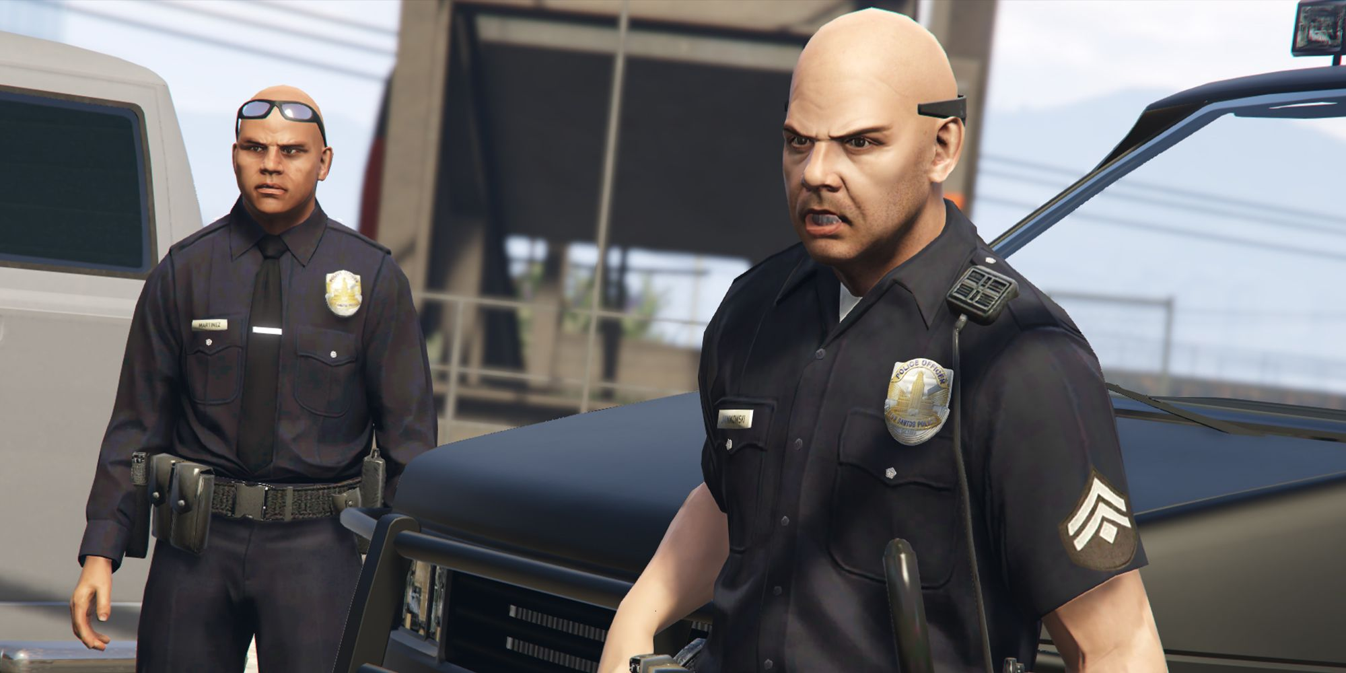

Thanos:



Krish:

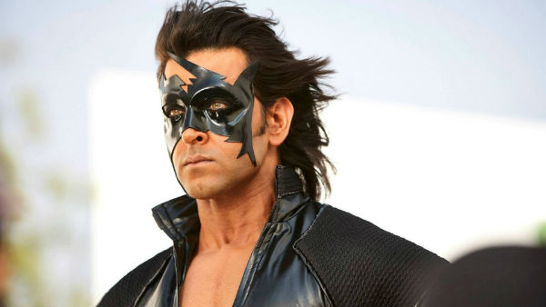

Soldiers:

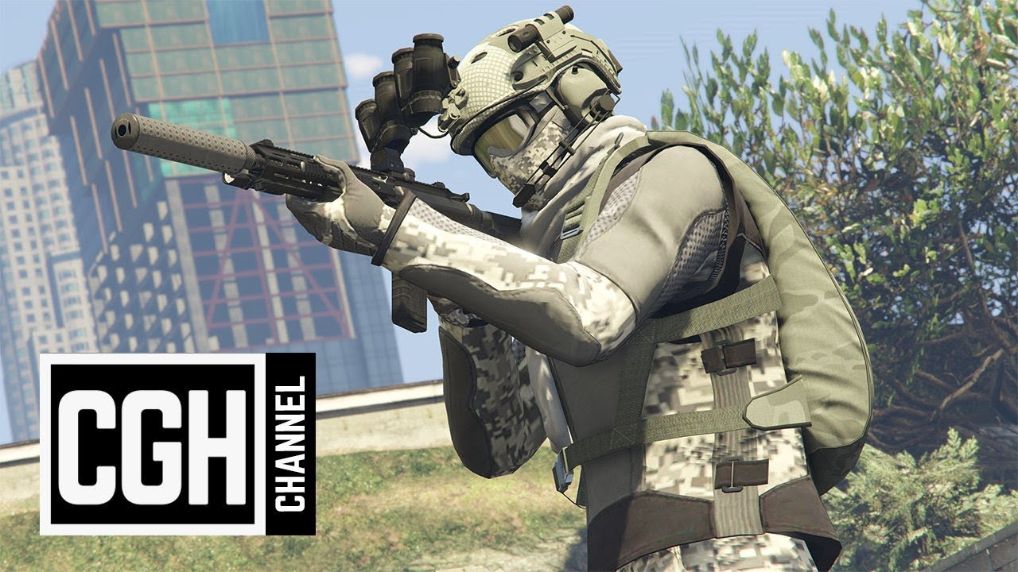

Presedents in meeting in story:

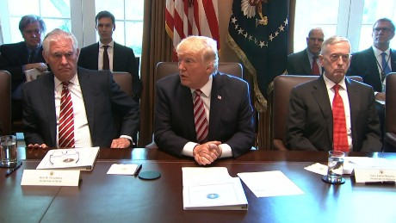

Trump:

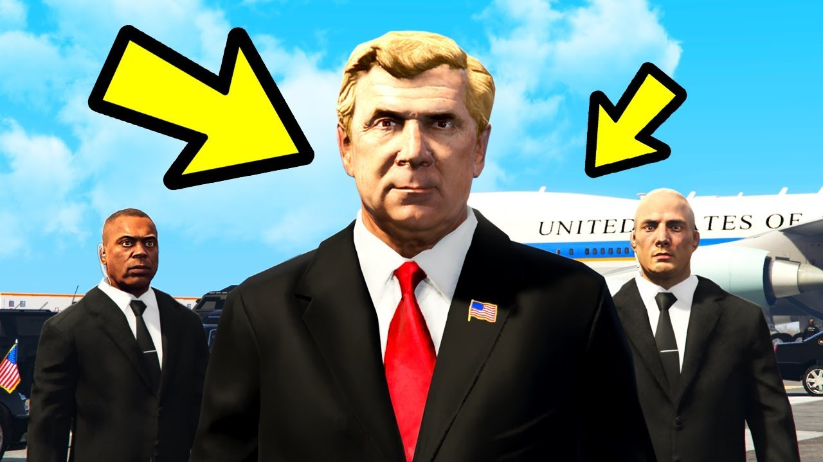

Non-Playing Characters

Message:



Granides:

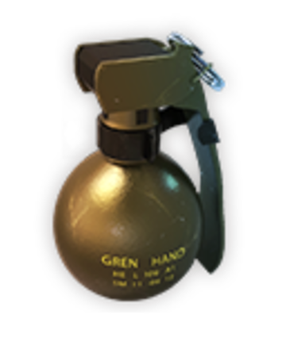

Gatling: Enemy weapon

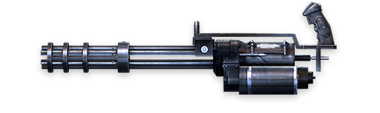

Earth:



Plasma:Soldier weopon:

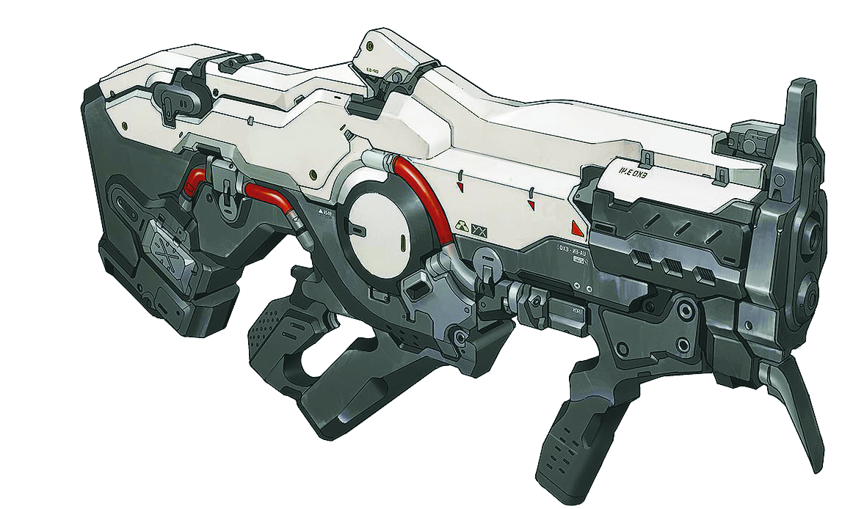

How do you plan to make your game engaging?

I planed a great story to make my game engaging.